SHOW MY HOMEWORK

Logging in as a parent
Your pin code is attached that you will need to use to access your Show My Homework parent account.

To log in on your computer, follow the steps below:

Using Chrome, IE etc

Search the following website address

https://www.showmyhomework.co.uk/login

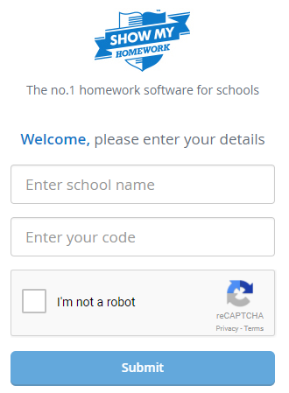
- Visit SMH website
- Click I've been given a PIN or Parent code to get into my account
- Search for your child's school (by name or postcode) in the top field
- Enter your code
- Tick I am not a robot and complete any security tasks if necessary
- Click Submit
On the next screen, add your contact details and choose a password. Press Update details when you're done.
Your account is now set up. Moving forward you can access your account using your email and password combination.

PTO

Logging in on the app
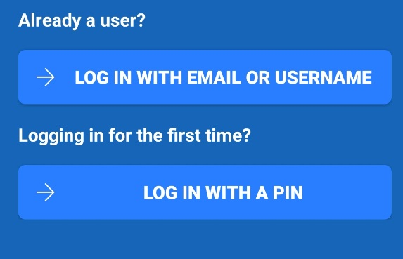

To log in on your phone via the Show My Homework app for iOS or Android, follow the steps below:
- Search for your child's school (by name or postcode)
- Tap Log in with a PIN or parent code
- Enter your PIN in the empty field
- On the next screen add your contact details
- You can also add your mobile number by tapping Mobile number if you would like to user your mobile number to recover your login details
- Tap Update Profile
Your account is now set up. Moving forward you can access your account using your email or username and password combination.

Forgotten Password
You can request a password reset email to the email you've registered with us by clicking Forgot password? on the Show My Homework login page. Once you have entered your email, a password reset email will be sent to you. If you do not see the password reset email in your inbox, you may want to check your junk or spam folder. Simply follow the instructions in that email to reset your password and regain access to your account.

